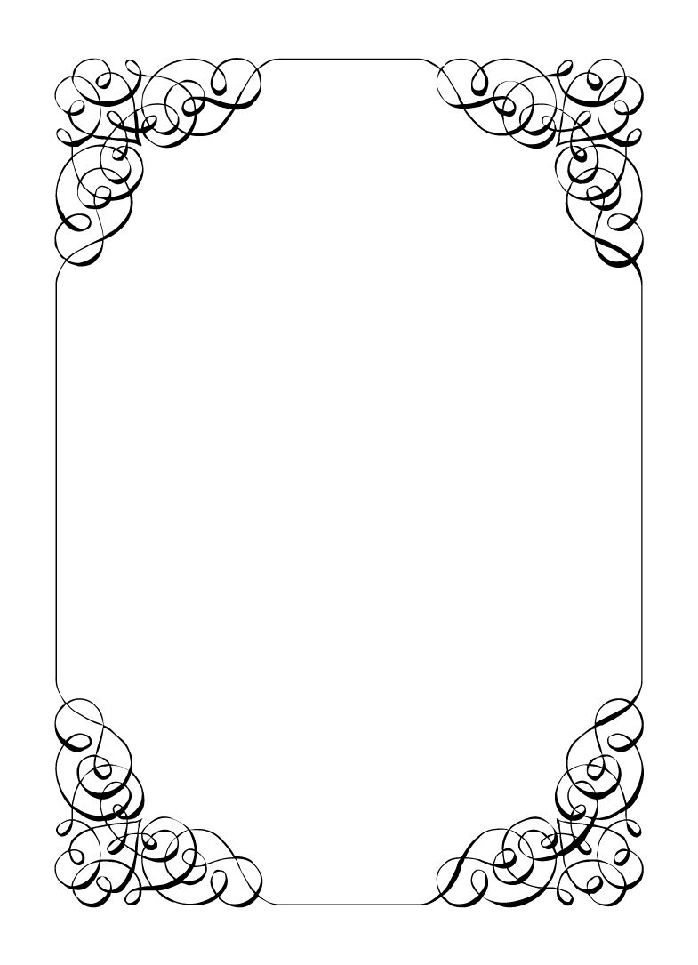

Not here to wed spiders

Gemini Belmont

*In the small town of Duck Rise, Victoria, Stralya live: BOGANS. Bogans are much like the regular folk, but drunker and louder. Some of them even fall in love. But before they settle down and poop out a mess of kids, they gotta have a wedding! Weddings are the best. Everyone gets proper plastered. Lots of kissing. Lots of drama. Fun times for all. Nothing ever goes wrong at a wedding...*  
*\*\*ominous thunder clack\*\**

Gemini Belmont

Maid of Honour *Steely, Action Hero, Traumatised*

You suffer no fools. Too bad the fools are all you can get in this wasteland. You like Corolla well enough. More like her please. You figured this wedding would be a good last hurra before you bailed on this town forever, and you are just hoping it goes well.  
  
Last Night: You attended the Bachelorette party. It was you, Corolla, Mercedes, Vectra, and Mungo. You had planned for it to be a night in of party games and romcoms, but Vectra had other ideas. She brought a bunch of the nicer boxed wine over beforehand and you pre-gamed a little too hard. The rest of the night was a blur. You vaguely recall a casino and getting donuts. You brought the wedding rings (which were your responsibility) to the party, but lost them sometime in the night. You have a massive headache and have vowed to never drink again. After the wedding.

**Goals**

* **Don't get married:** Make sure the Bride makes it down the aisle in one piece, you definitely don't want to accidentally get married.
* **Find the ring before anyone else:** You lost it, so you must find it to restore Corolla's faith in you. Someone must of seen it after last night.
* **It's lucky they say...:** Find something borrowed, something blue, something old, & something new and give them to the bride. (Item cards will help you)
* **Make Mercedes act her age:** Mercedes acts far too adult for her age, as her past baby sitter you are responsible for making sure she can stay a child.
* **Have a fling with the best man:** If you are the Maid of Honour its only natural you get with the Best Man, whomever that is...
* **Don't work on your day off:** You are an off-duty cop, you absolutely refuse to do any police work at this wedding.
* **Catch the bouquet:** You are the Maid of Honour. It is the correct action if you catch the bouquet.

**Other People**

**Corolla Castro**

Like a whirlwind, Corolla makes the world revolve around her. Deep down you know she cares for you deeply, but she rarely stops long enough to show it.

**Mercedes Bennie**

You used to be Mercedes's babysitter before your career started. Her attitude has completely changed since you came back and you can't help but feel somehow she holds you responsible.

**Robin Smith**

Where does Corolla find these people. Robin is so obviously out of place that you can't help but feel sorry for them.

**Dave Torana**

He seems a little much. Too confident and far too much chest hair. If he wasn't the best man you would not be interested at all. Alas he is.

**Malibu Singer**

Malibu is Corolla's other best friend. These is a friendly rivalry that has developed over the years, and it seems that as Maid of Honour, you have won.

**Sparkie Castro**

Corolla asked you to keep Sparkie away as he is 'ruining the mood'. He doesn't seem that bad but family can be weird sometimes.

**Vectra Marolla**

You met for the first time at the Bachelorette party, and she was a wild animal. You and her got your drink on and you feel like you bonded over her daughter.

**Wayne Marolla**

Your police training has made you hyper aware of creepy old men like Wayne. You are certain he has been watching you closely since arriving. Hopefully it is ring related.

**Mungo Joint**

Looks tired. Perhaps you should offer a hand if you get a spare second.

**Abilities**

Use these to do things. They have a limited use, so check them off when you use them.

|  |  |
| --- | --- |
| Ability | Bust some heads |
| Glare at someone from across the room for 30 seconds. March over to them and then demand they tell you the truth. The player must show you their information. |
| Usages: O O O |

|  |  |
| --- | --- |
| Ability | This is evidence.. delicious evidence |
| Talk to an Organiser and specify a player and an item. If the player has such an item, you will steal it from them. If the player doesn't, you will steal an item at random. If they have any beer on them, you get that instead. |
| Usages: O O O O |

|  |  |
| --- | --- |
| Ability | Oh do I have a story for you |
| Tell someone a cute story (make it up) about the Bride. The player must show you their secret. |
| Usages: O O O |

**Secret and Information**

Your Secret contains your guilty secret, while your Information contains one or more items of information you know. Both may be affected by abilities. Your lie may need to be filled out later.

While you can show your Secret and Information to whomever you like, you will probably not want to reveal your Secret too often. (Please note that you can’t solve the crime by looking at everyone’s Secret and Information – it’s not that easy!)

|  |  |
| --- | --- |
| Secret | During cop academy you became an alcoholic, last night you were black out drunk and lost the ring at the casino. |

|  |  |
| --- | --- |
| Information | You heard the ring came from Wayne. |

**The Organiser’s Word is Law:** The organisers are impartial. If you have a problem or want to do something unusual, see an organiser. The organiser’s power is absolute – and cannot be affected by ability cards!

**Winning and Losing:** You can achieve most of your goals simply by talking to people. The organisers will announce when the game is over. If you haven’t succeeded by that point – you’re too late! Be warned – not everyone here will want you to succeed!

**Doing Stuff:** Ordinary actions are resolved by simply carrying them out. If you want to try something unusual (such as trying to hack the pentagon), see an organiser. The organisers knows everything – and will be able to tell you the outcome of whatever it is that you are trying to do. (For example, you are trying to hack over state lines and you are caught.) Do use your imagination, though! – this is a very flexible game, and you can do all sorts of things beyond what’s listed in these rules.

**Fighting:** If an ability or item lets you hard another player, don’t just dive in! See the organisers first and tell them what you plan to do so they can oversee and give you more detailed rules if it’s necessary.

**Leaving:** You cannot leave, it is rude to leave a wedding and you are in the middle of nowhere!

**Role Cards:** If someone asks you for your role in the wedding ceremony, and you have one, you must show them all your roles.

**Item Cards:** Any items of importance within the game are represented as Item cards – and the only items that can affect the game are those detailed on the cards. If you do not have an Item card, you do not have that item with you.

**Time:** This game is played over three (ish) hours, including time for reading your character etc. There will be breaks throughout the evening! The organisers will tell you when each period starts and finishes.

**Character List**

**Chad Marolla – *Groom***

The soon to be husband. A bit nervous about the wedding, but is letting Corolla take care of the hard stuff.

**Corolla Castro – *Bride***

She knows what kind of wedding she wants, and that's the kind of wedding we are having! NO EXCEPTIONS!

**Gemini Belmont – *Maid of Honour***

She carries herself like she just escaped a warzone. Maybe she did? She's real quiet and might throat punch you if you ask stupid questions.

**Mercedes Bennie – *Flowergirl***

She's 12 but everyone knows better than to treat her like a 12 year old. Punk AF and will burn this all down on a whim.

**Robin Smith – *Priest***

Not from here. Better than everyone else (or at least thinks so).

**Dave Torana – *Best Man***

Childhood friends with the Groom. He was the smooth talking hottie that picked up enough for both of them. But that part of his life is over now.

**Malibu Singer – *Wedding Planner***

For a professional organiser, not very organised. Has just managed to keep everything running so far.

**Sparkie Castro – *Bride's Father***

He's been waiting his whole life for this moment. His baby girl is finally gonna get married and he knows just how to get through the day without crying...

**Vectra Marolla – *Groom's Mother***

The Queen that runs this town. Knows where the bodies are buried, but will never tell. Everyone respects her.

**Wayne Marolla – *Drunk Uncle***

He's maybe had a few too many. Started stumbling around and saying weird things. Every wedding has one.

**Lucky the Wonder Dog – *Dog***

A good dog. *bark* *bark* "What's that Lucky? You want pats?"

**Mungo Joint – *Photographer***

Seems like they are creeping on everyone, but they were hired to take wedding photos so it's probably fine.